Updates - Week 4/28-5/4 (Final Update):

- 6 sounds have been added and programmed into the game
  - 5 second startup track
  - Ambient space track for gameplay
  - Laser sound that occurs when the player shoots
  - A collision sound when a laser hits an asteroid
  - A collision sound when the player collides with an asteroid
  - A level up sound
- Levels rebalanced
  - Math calculations affecting asteroid scale, speed, and frequency have been modified to rebalance across levels, making for smoother transitions between levels
  - The timer during gameplay has changed to get shorter, not longer, to make for more of a challenge when levels ramp up
- All time based calculations have been attached to delta time
- Level counter UI has been modified to blink upon level up, creating a visual and an auditory cue
- A new class, DeadAsteroid, has been added in order to keep asteroids still when blown up and not collide with the player
- Player movement has been sped up, both rotation and movement speed
Updates - Week 4/20 - 4/27 (Graphic Demo):

- Asteroids move in only random directions, not necessarily towards the player
- Level progression doesn’t result in a win message
  - A score has been added to keep track of player progress
- Pausing the game doesn’t allow the player to restart the game, but instead to exit the game
  - Losing does give the player the ability to restart
- Player constructor does not include width or height, only x and y
  - Player sprite is pre rendered, so the size is taken from the image
    - This also means there is no color argument
      - All of this goes for all sprite classes
- Move methods are not methods, but simply calculations within the update method
- Destroy method has been named handleCollisions
  - This goes for all sprite classes
- Asteroid variables such as movement speed, size, etc. are now determined by the level count
  - Calculations are done to the level count to determine speed and size

Written Description

Game Concept:
Project 10 for Game Simulation will be an Asteroids clone. The goal will be to, within the window, have a player-controlled sprite, that looks like an arrow, shoot little lines from the player in a straight line in whatever direction the player is facing. Aside from rendering the player sprite, there will be asteroid-like sprites rendered outside the window, traveling through the window at a random controlled speed, attempting to collide with the player. The player must shoot their lines at the asteroid in order to destroy the asteroids before the asteroids collide with the player, resulting in a game over message and the inability to continue.

Game Mechanics:
- Render an arrow sprite, controlled by the player.
  - Sprite will render a little line that travels at a constant speed
  - Both player sprite and rendered lines shot from the player will have collision detection
- Render random asteroid-like sprites
  - Asteroid sprites will render off screen
  - Asteroid sprites will travel through the visible screen
  - Asteroids will have a random speed
  - Asteroids will travel in a random direction, though some will travel towards the player
- Level gameplay loop
  - Levels will increase the amount of asteroids at any given time
  - Levels will increase the highest amount of speed an asteroid can have
  - Levels will be time based
- Pause function
  - When the player presses a key, the entire loop will freeze
  - Pause will be displayed in the middle of the screen
  - An option to restart the game will be displayed underneath the Pause message
- Win/Lose function
  - For each level that passes successfully, a win message will appear
  - If the player loses, a lose message will appear
    - The player will have the option to restart the game
k
Game UI:
- Level and level counter will be displayed in the top left corner of the window
- Time left will be displayed in the upper middle of the window
- Keys and their functions will be displayed in the bottom right corner of the window
  - Space will shoot the line
  - WASD will control the player
  - P will pause the game
    - On pause,
- Pause message will appear in the center of the window if the player pauses
- Win/Lose message will appear in the center of the window if the player wins or loses
- Sound will play when the player shoots from themselves
  - Sound will play when an asteroid is shot
  - Sound will play when win/lose message occurs

User Input Design

If SPACEBAR:
- A line will spawn from the tip of the sprite and travel in a straight line at a high speed
If K_P:
- The pause screen will display
  - The simulation will freeze entirely
If K_W:
- The player sprite will move in the direction the player sprite is facing
If K_A or K_D:
- The player sprite will rotate left if A, and right if D
If K_S:
- The player sprite will move backwards in the direction the player sprite is facing
When the level has ended:
If “You Win!”:
- “You win!” Will display
  - Spacebar will continue to the next level
If “You Lose!”:
- “You lose!” Will display
  - “Replay?” Message will display below
  - Press y to restart
  - Press n to close the window
Technical Outline
Player Sprite:
Constructor Arguments:
- Self
- X, Y - starting origin
  - Origin point will always be in the center of the screen
- Width, Height - size
- Color
- Speed
  - Speed will always be constant

Move Method - Arguments:
- Self
- DX, DY - A plus-equal location

Spawn shoot method
- Calls Shoot class

Destroy method
- Upon collision, the sprite will be destroyed

Shoot Sprite:
Constructor Arguments:
- Self
- X, Y - starting origin
  - Origin begins at the tip of the player sprite
- Width, Height - size
  - Size is constant
- Color
- Speed
  - Speed is constant
Constructor Behavior:
- Line will move automatically
  - Movement will be determined by class variables

Destroy Method:
- Upon collision, an asteroid will be destroyed
  - Line will also be destroyed
- Upon exiting the screen, the line will be deleted

Asteroid Sprite:
Constructor Arguments:
- Self
- X, Y - starting origin
  - Origin point will be random, typically off screen
- Width, Height - Size
  - Size will be random
  - Minimum and Maximum
- Color
- Speed
  - Speed will be random
  - Minimum and Maximum

Destroy Method
- Upon collision, the sprite will be destroyed
  - The player sprite will be destroyed upon collision
  - The asteroid will be destroyed upon collision with shoot

Storyboard Annotation
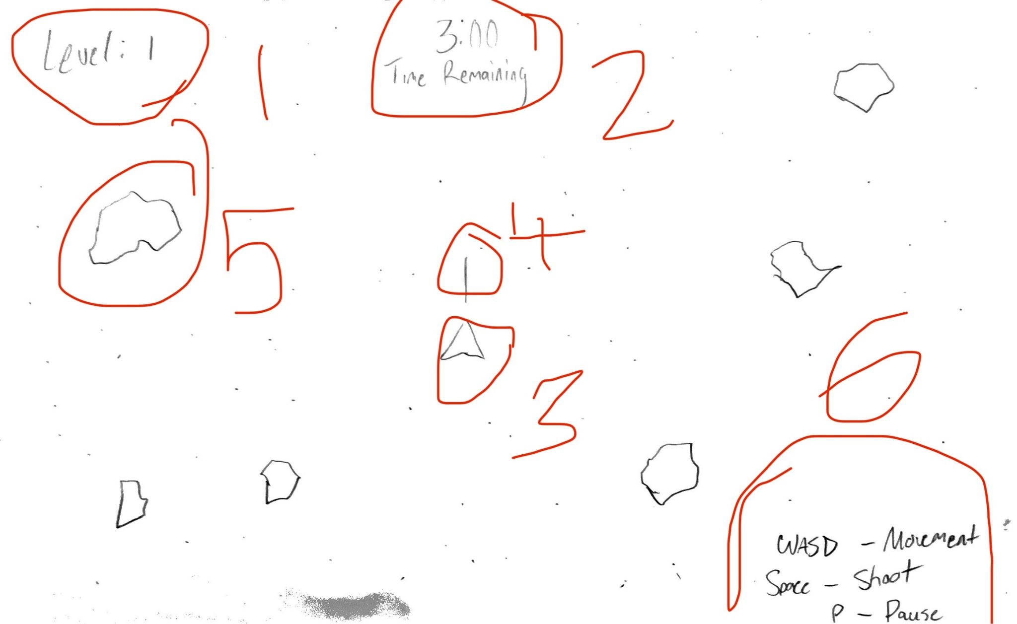
1: Level and level incrementer
2: Time remaining
3: Player Sprite
4: Shoot sprite
5: Asteroid Sprite
6: UI Details

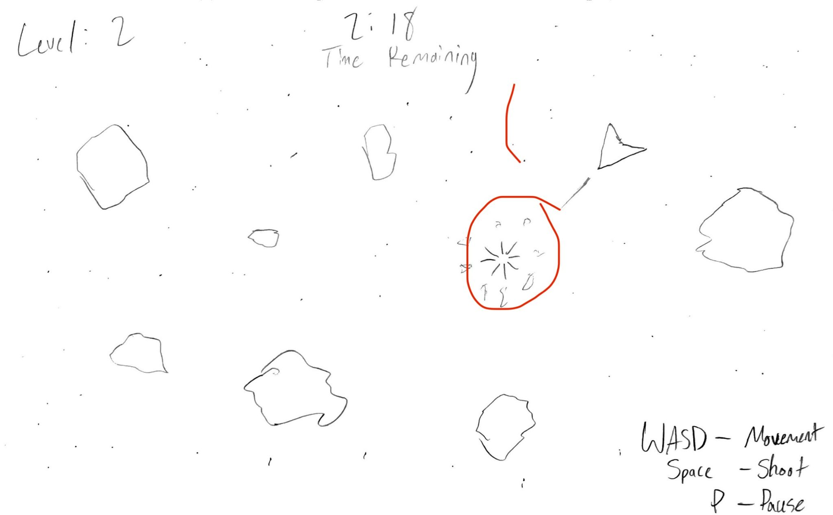
1: Collision when a shoot sprite hits an asteroid sprite
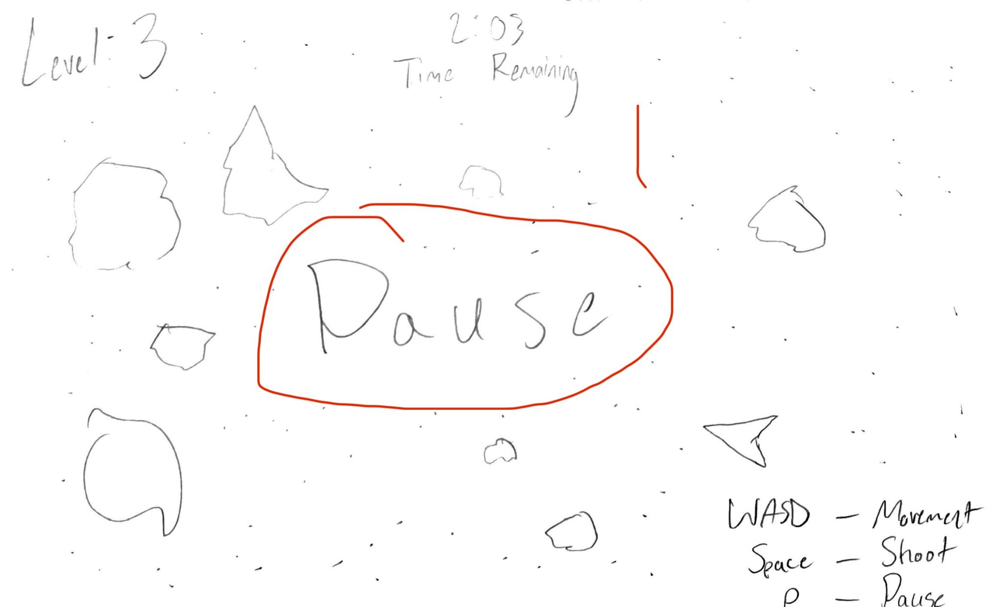
1: Pause message
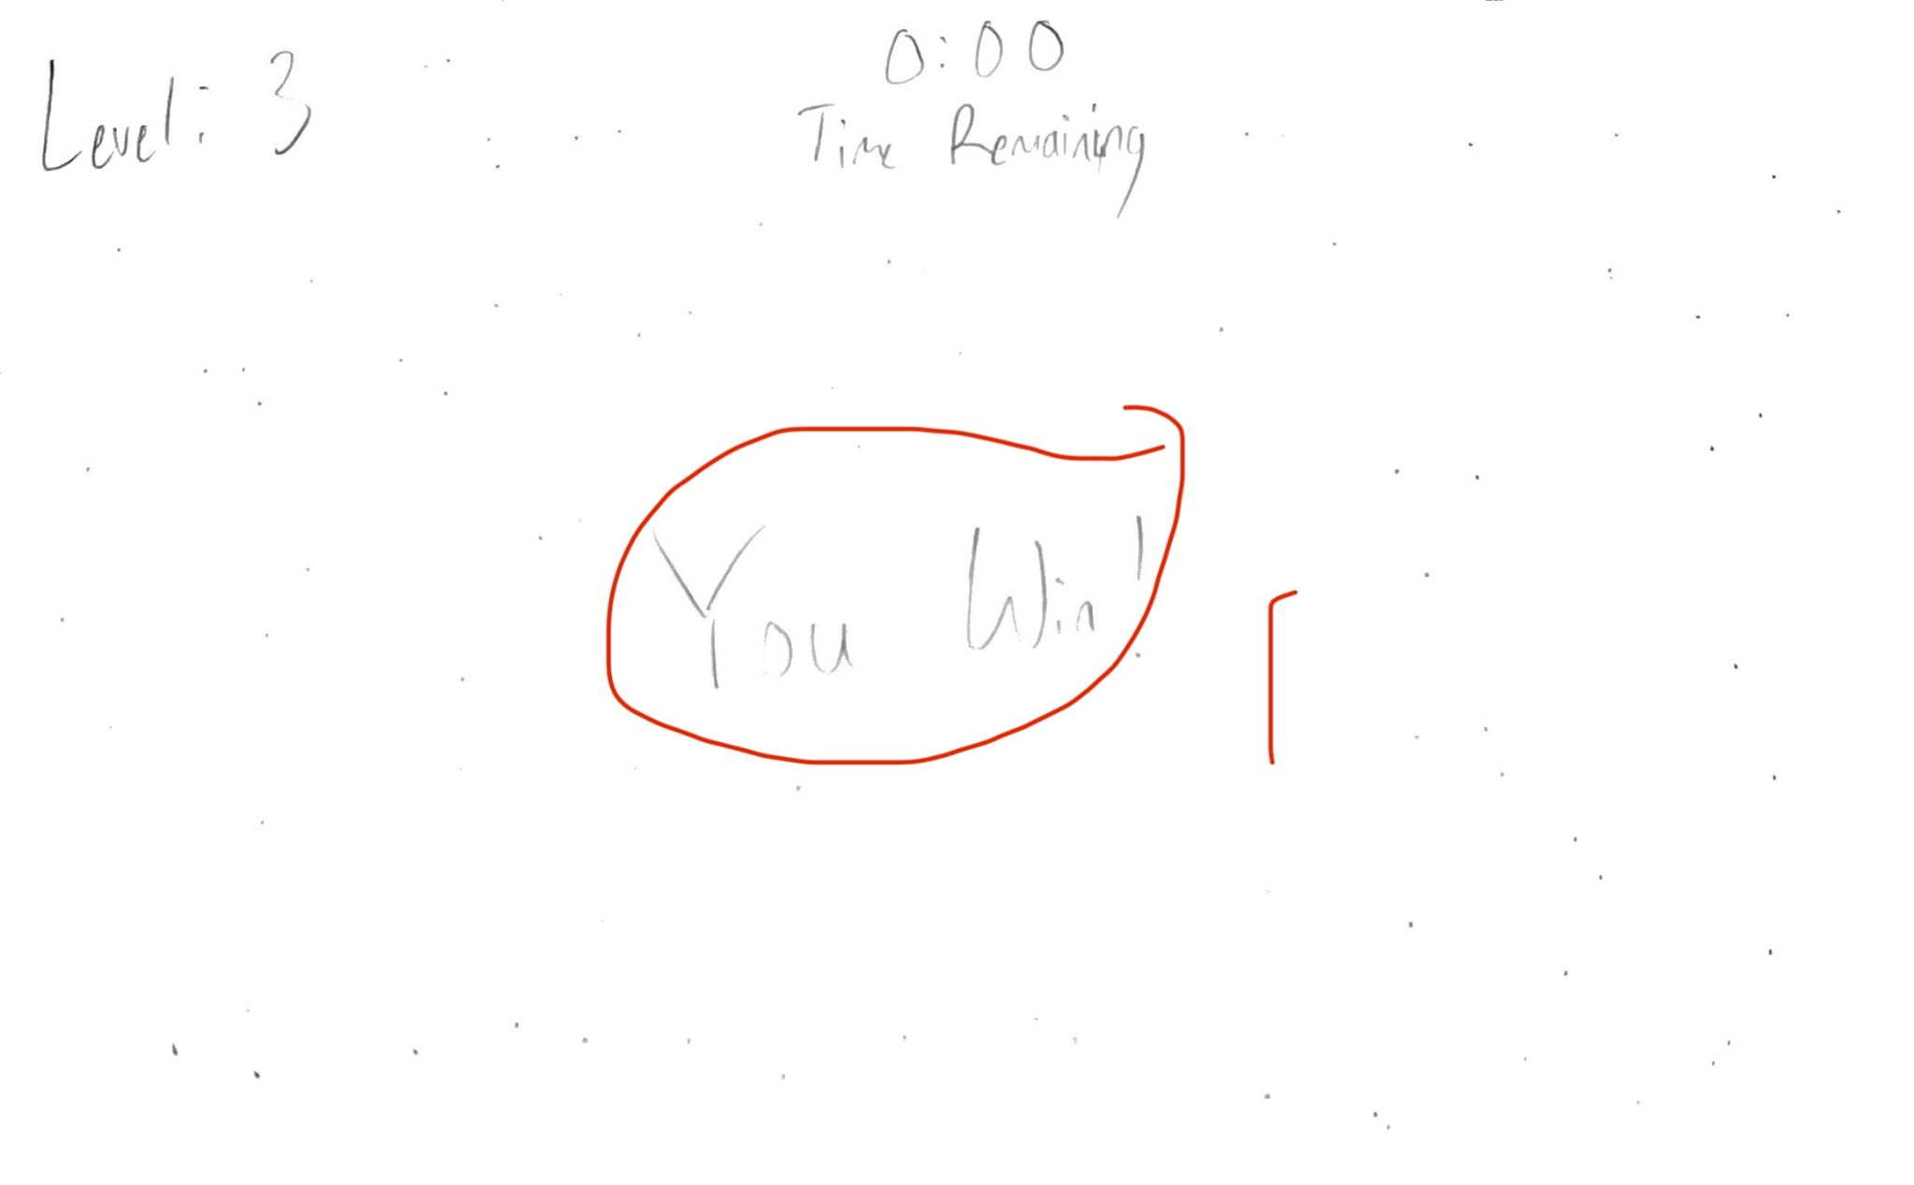
1: You Win! Message upon level completion
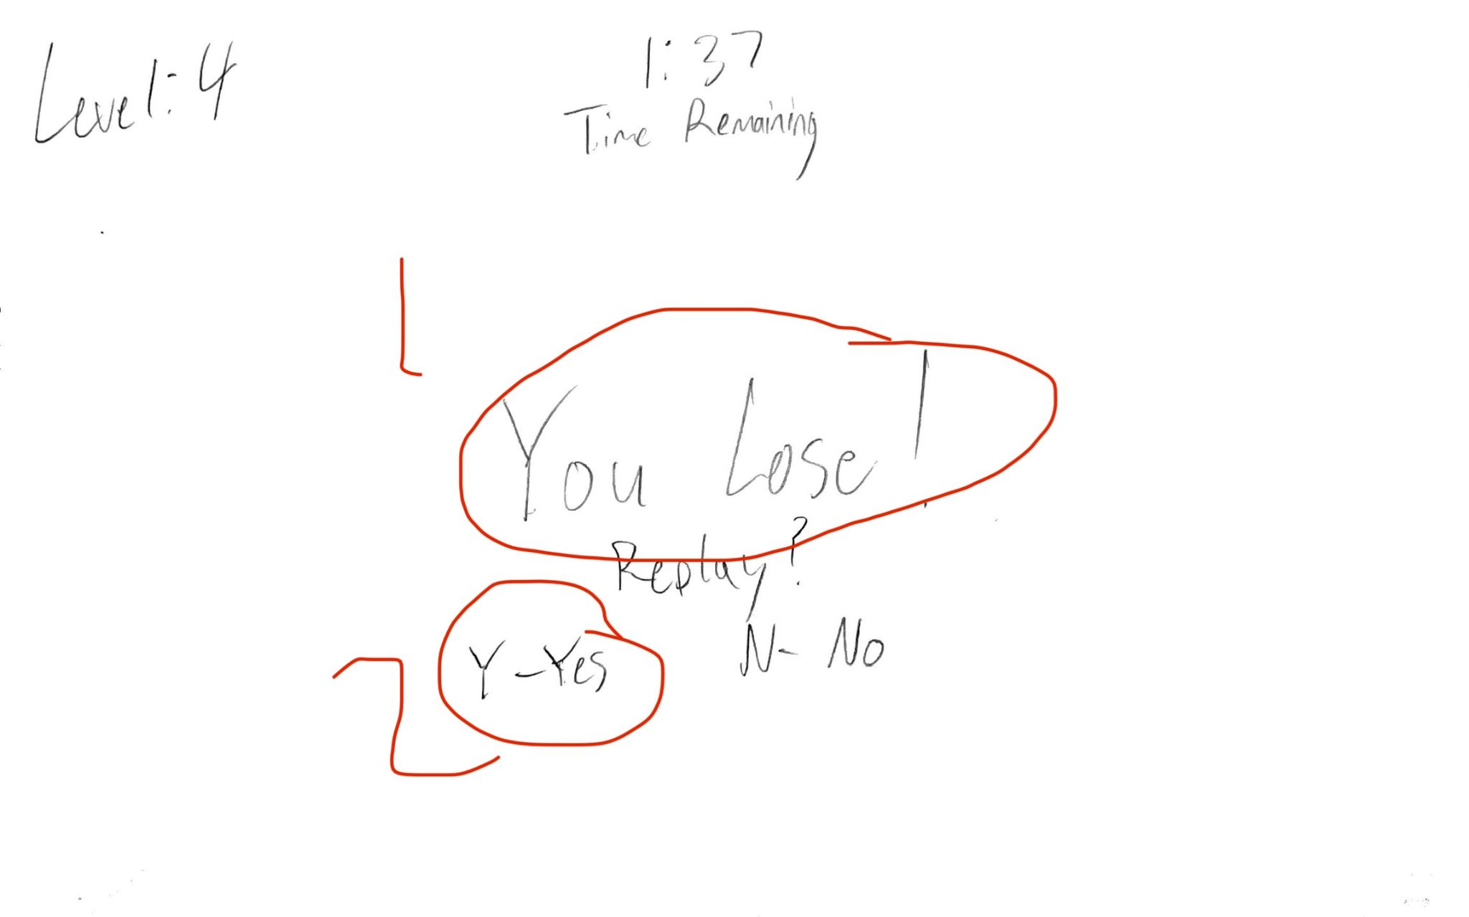
1: You Lose! Message displayed
2: Option to reply

